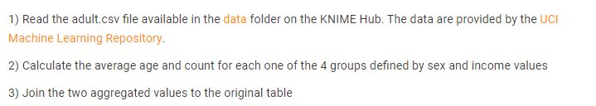

- Read the adult.csv file
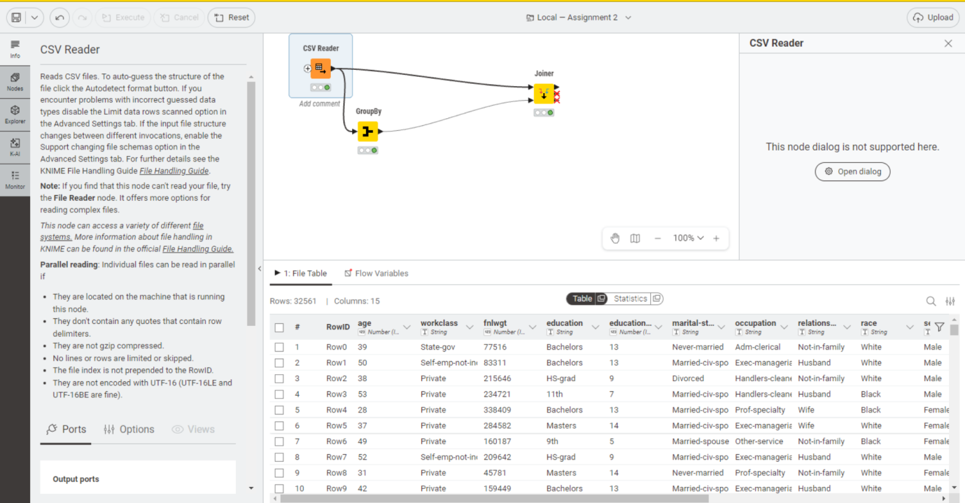

- Calculate the average age and count for each one of the 4 groups defined by sex and income values
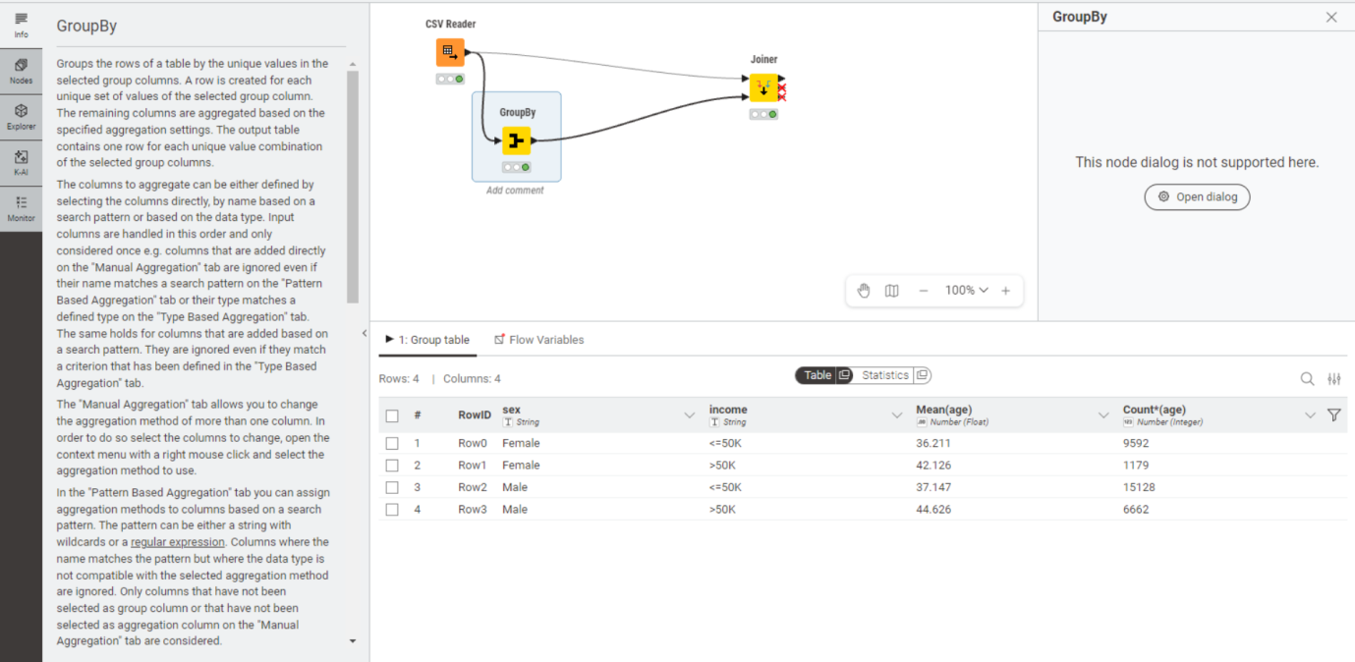

- Join the two aggregated values to the original value
